# Overview

This lab will introduce the Watson Machine Learning capability using the Titanic dataset. The lab will consist of the following steps:

1. Setting up the environment
2. Adding a data asset to the DSX Labs project
3. Creating a Model to predict whether a person would survive
4. Deploying and Test the Model

# Step 1: Setting up your environment

To use IBM Watson Machine Learning you must have the following service instances in your Bluemix dashboard:

* Watson Machine Learning
* Object Storage
* Apache Spark

The Object Storage and Apache Spark service instances should already exist having been created when your DSX account was provisioned. We now need to provision a Machine Learning Service.

### Step 1.1: Creating a Machine Learning Instance

To create a Machine Learning service instance, you must perform the following steps:

1. Log into Bluemix at [www.bluemix.net](http://www.bluemix.net).

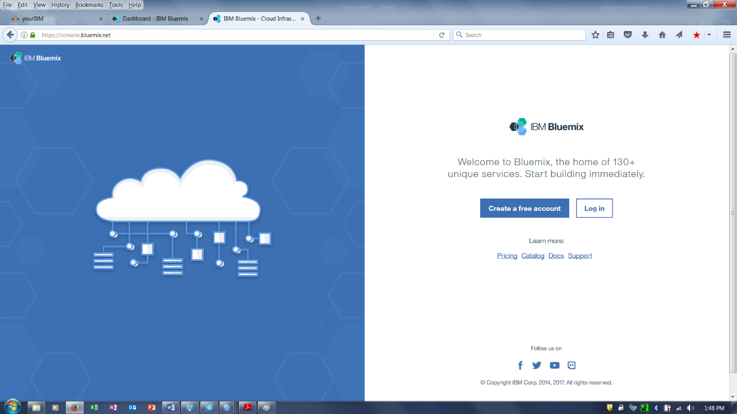

1. Once logged in, click on the hamburger icon, and from the navigation panel, click **Data & Analytics**.

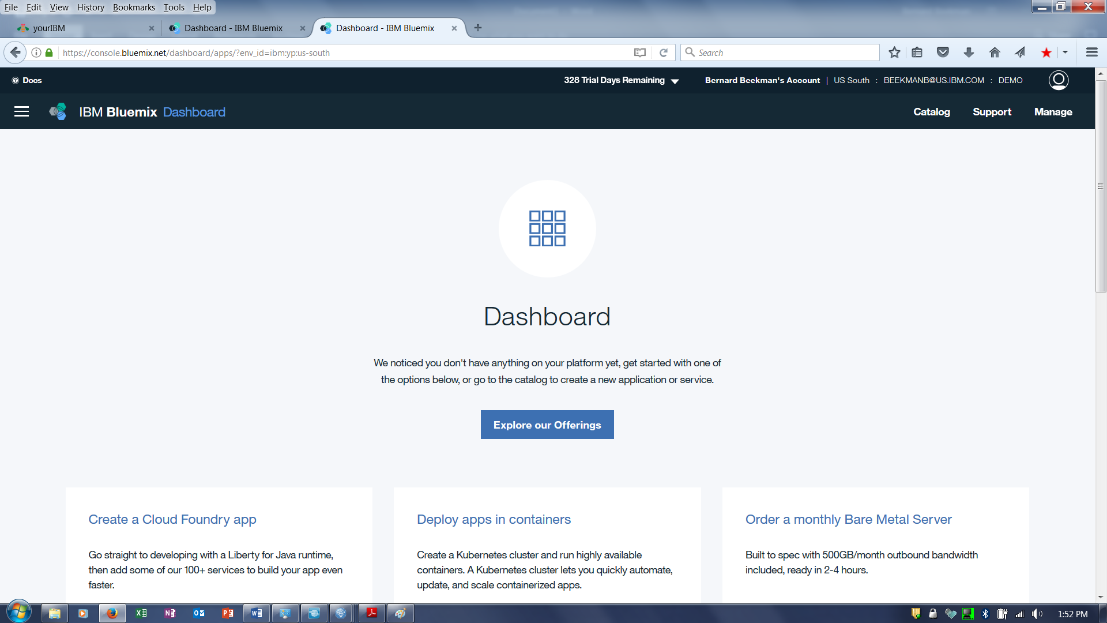

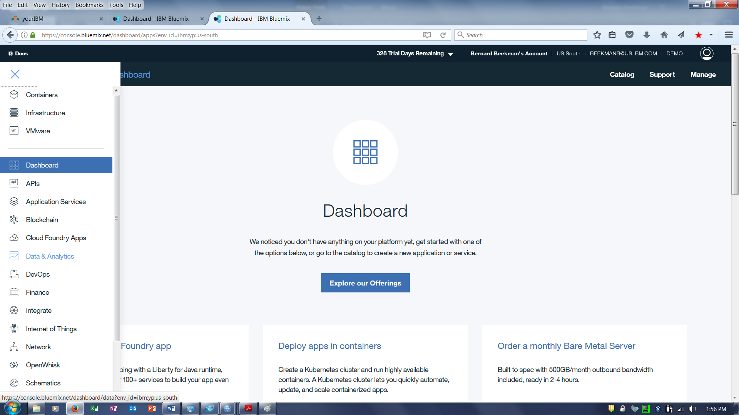

You see a screen centered on data services. You can return here regularly to work with your data and analytics services from one easy-to-use page. Check to see if a Machine Learning service already exists. If not, continue, otherwise go to Step 1.2: Adding existing Bluemix instances to a project in Data Science Experience

1. Click the **Create Data & Analytics Service** button.

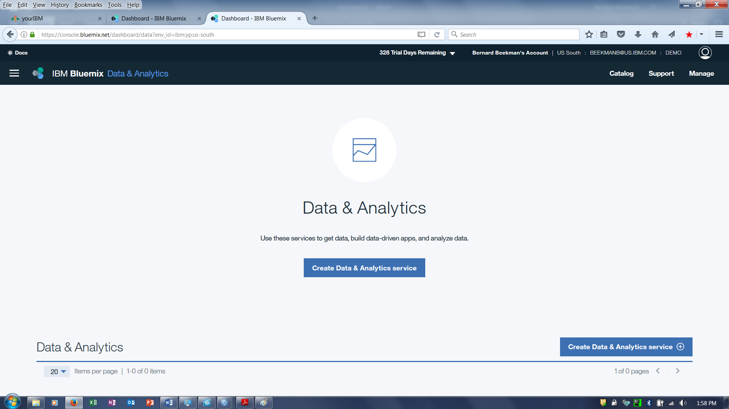

1. **Scroll** down to Machine Learning and click.

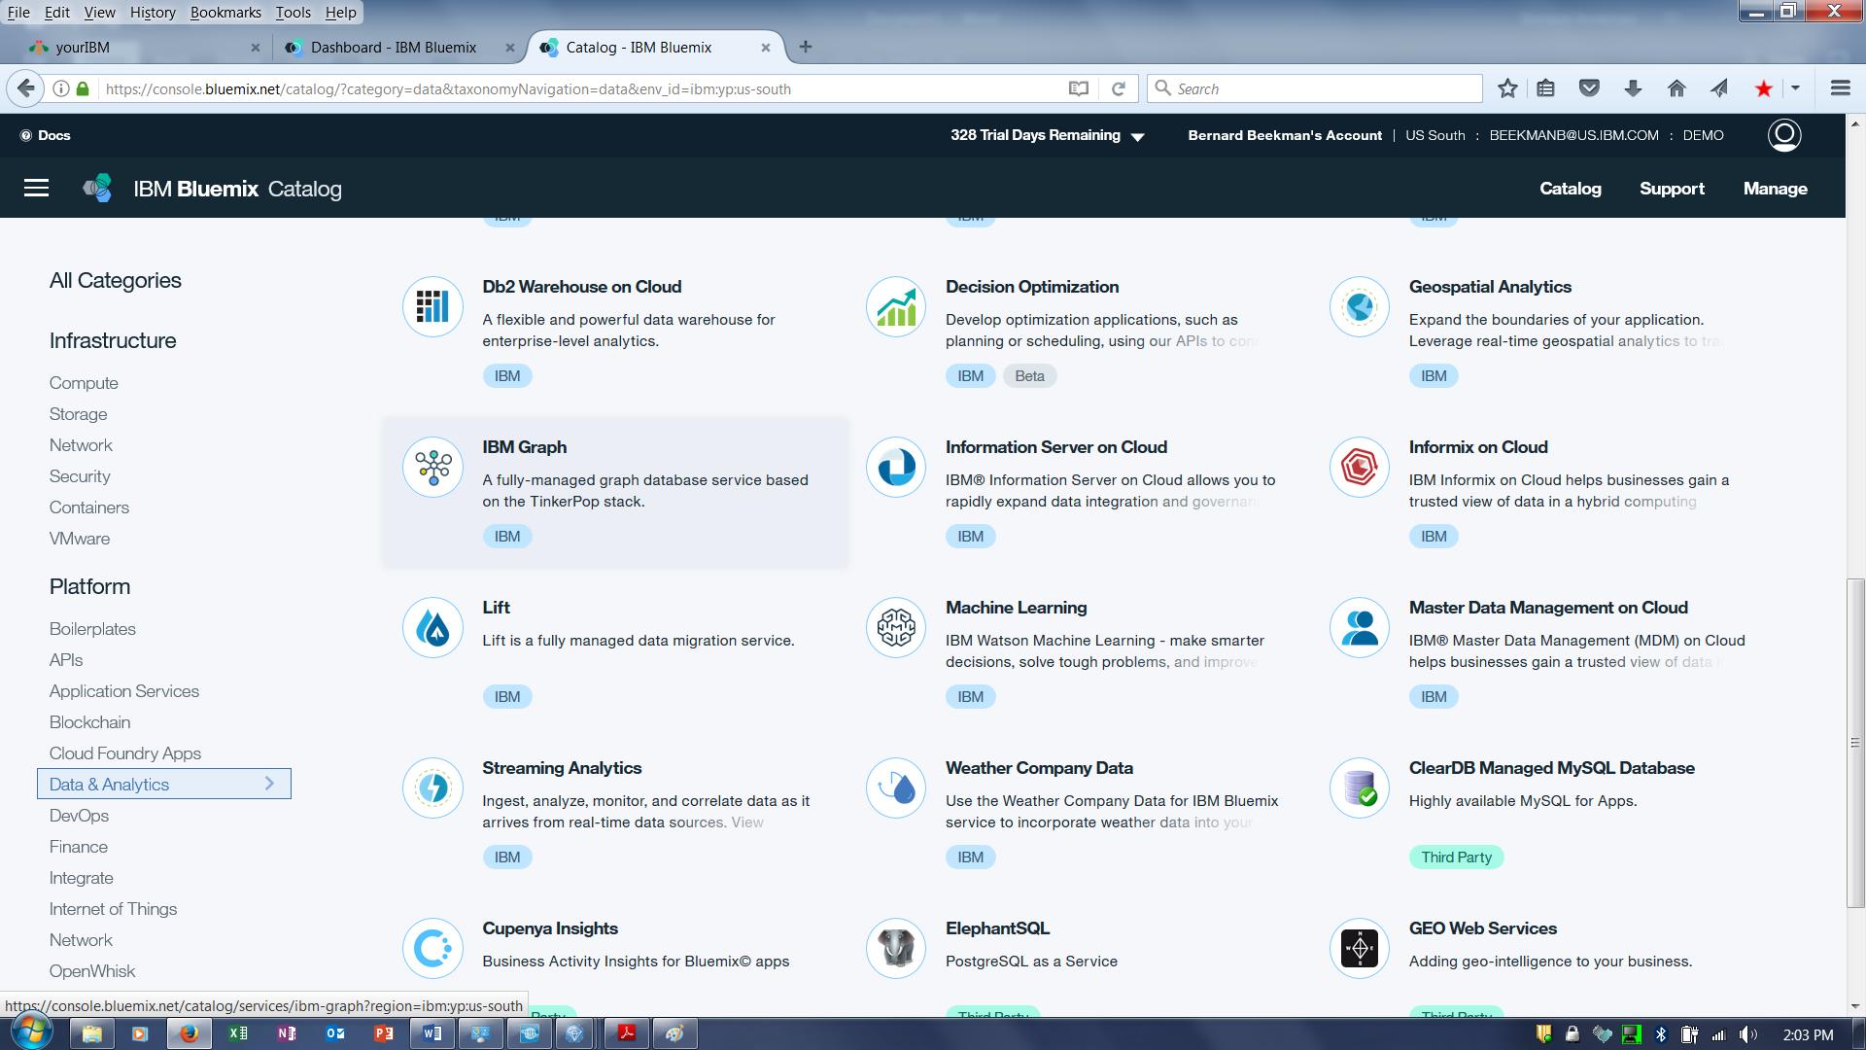

1. Configure service.

Enter a descriptive name for your service, choose a space, and select your data plan (find plan comparison and pricing details on this page). Click on **Create**.

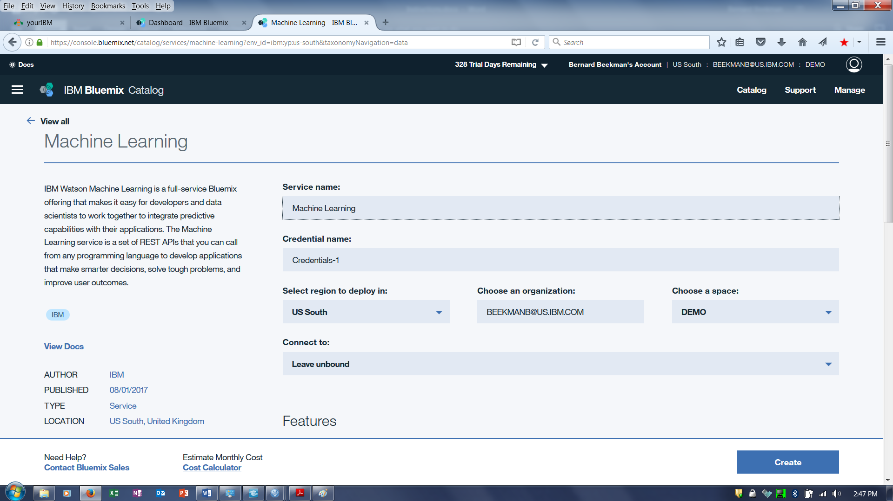

### Step 1.2: Adding existing Bluemix instances to a project in Data Science Experience

If you already have instances, but have not linked them to a project in Data Science Experience, you must perform the following steps:

1. Log on to IBM Data Science Experience – <https://datascience.ibm.com>

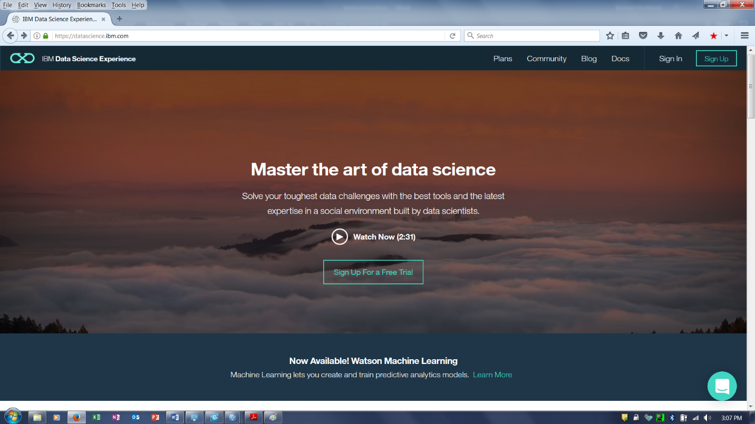

1. Click **Projects** > **View All Projects**.

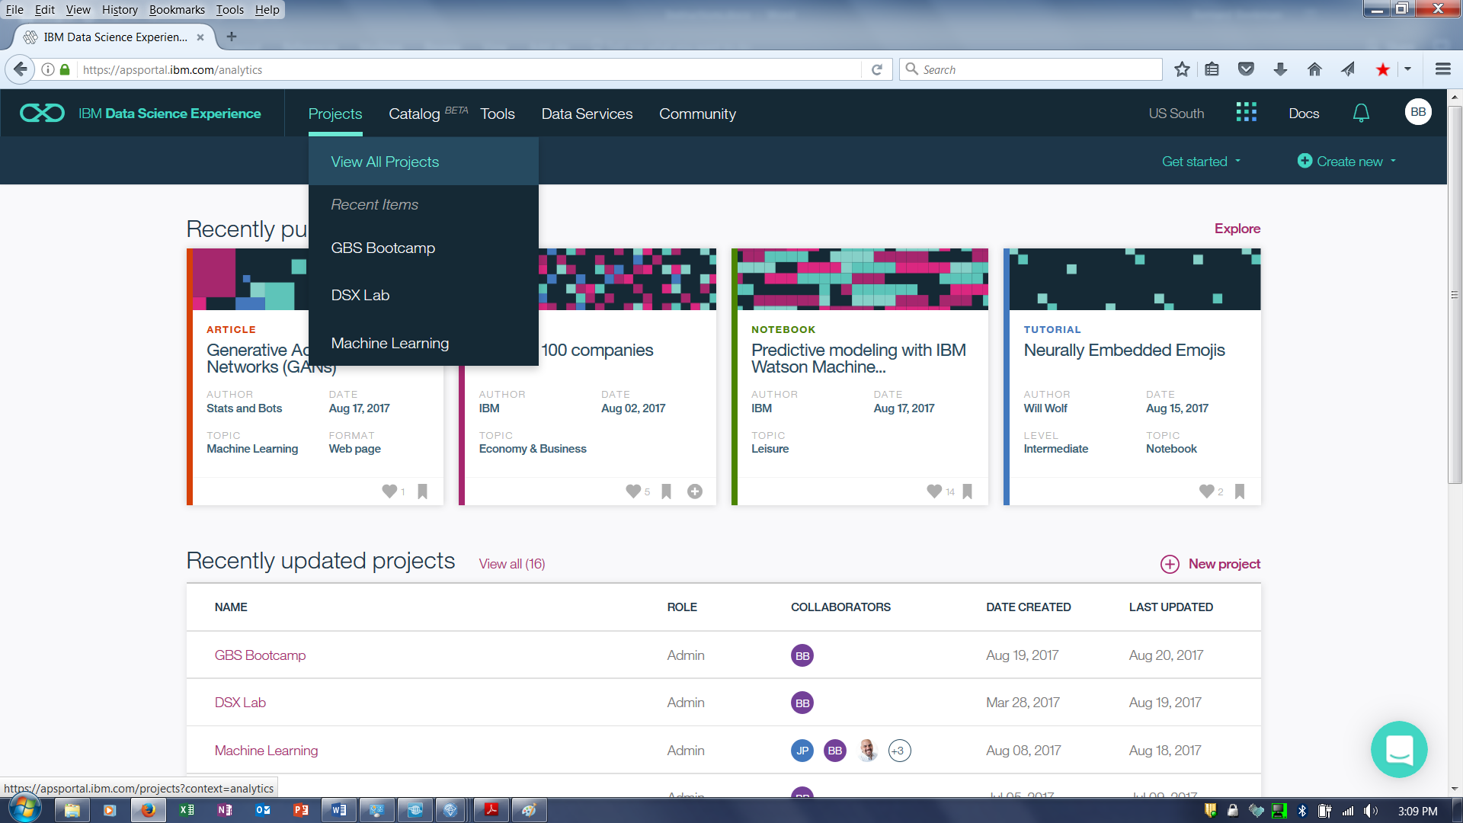

1. Click on the project that you created in the prerequisites, or if no project was created you can either create one, or click on the default project. (For the remainder of this document, I’m assuming the project name is DSX-Labs).

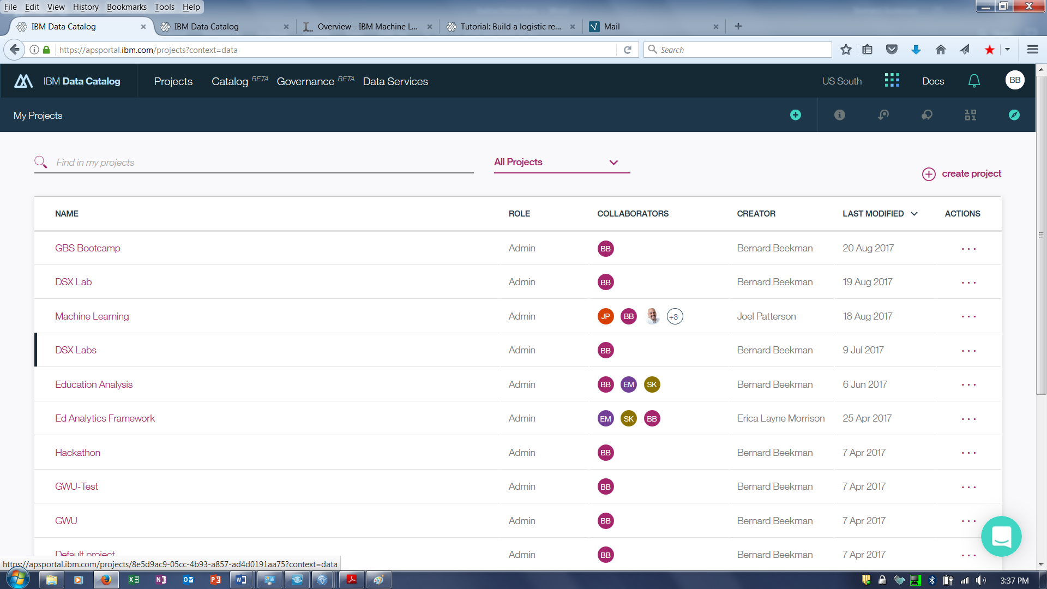

1. Select the **Settings** Tab.

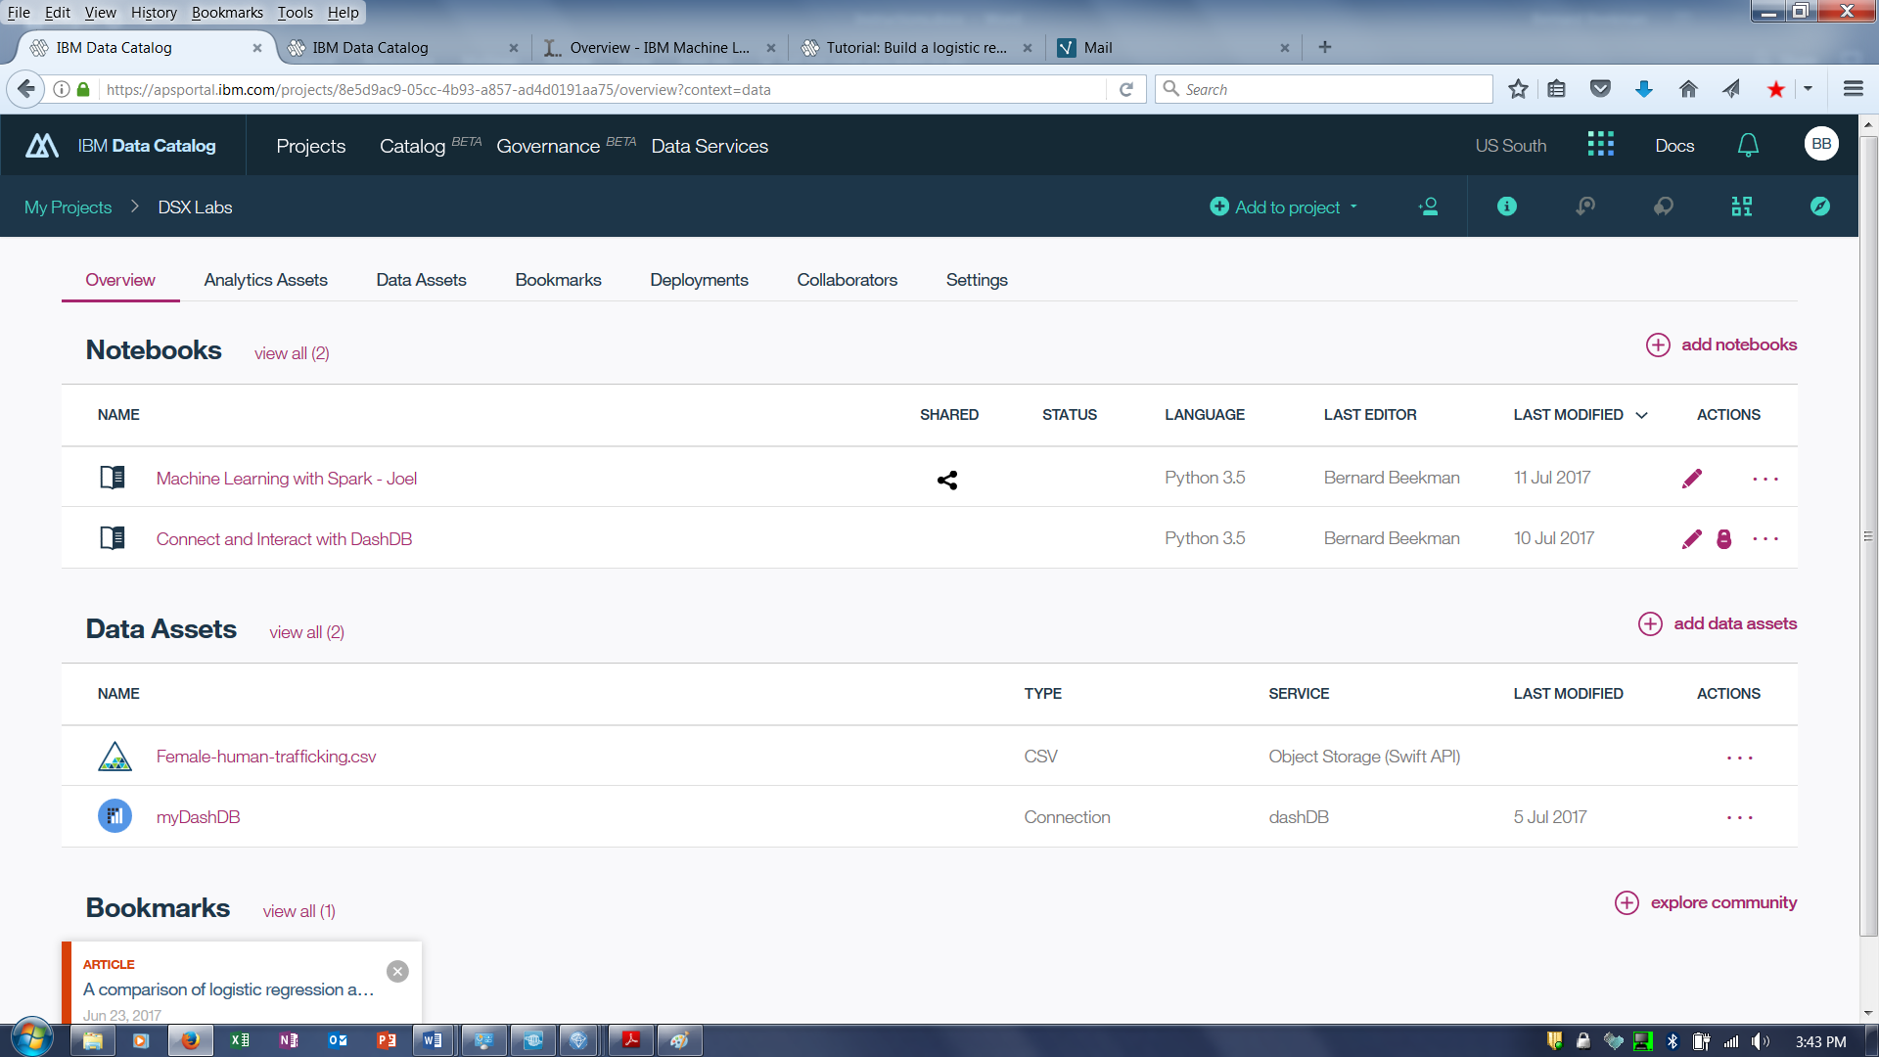

1. Scroll down to Associated Services. To add a service, in the **Associated Services** panel, click **add associated service**, select the Machine Learning service.

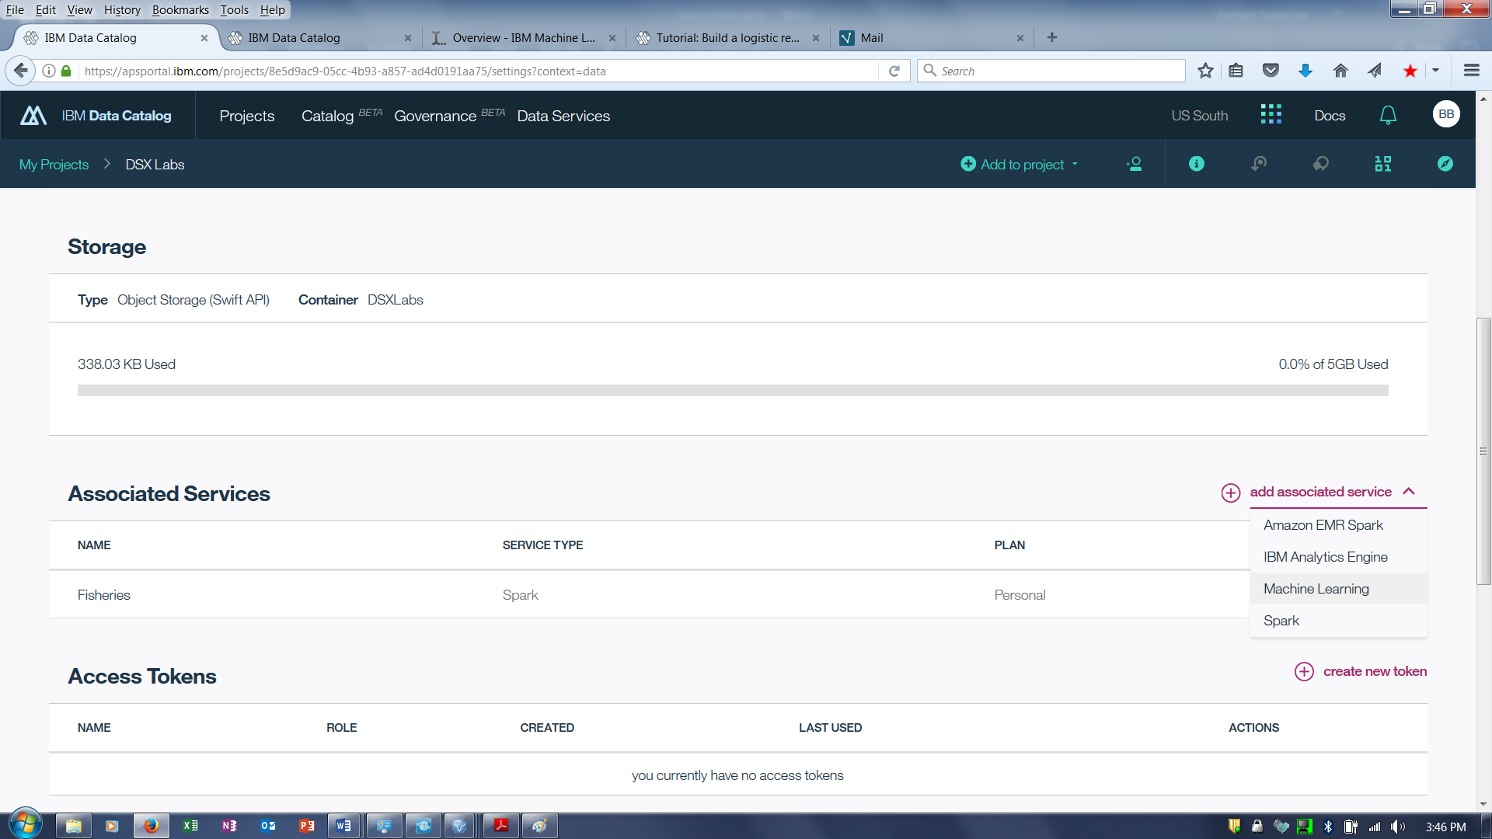

1. Select the Machine Learning service instance from the drop down list and then click **Select**.

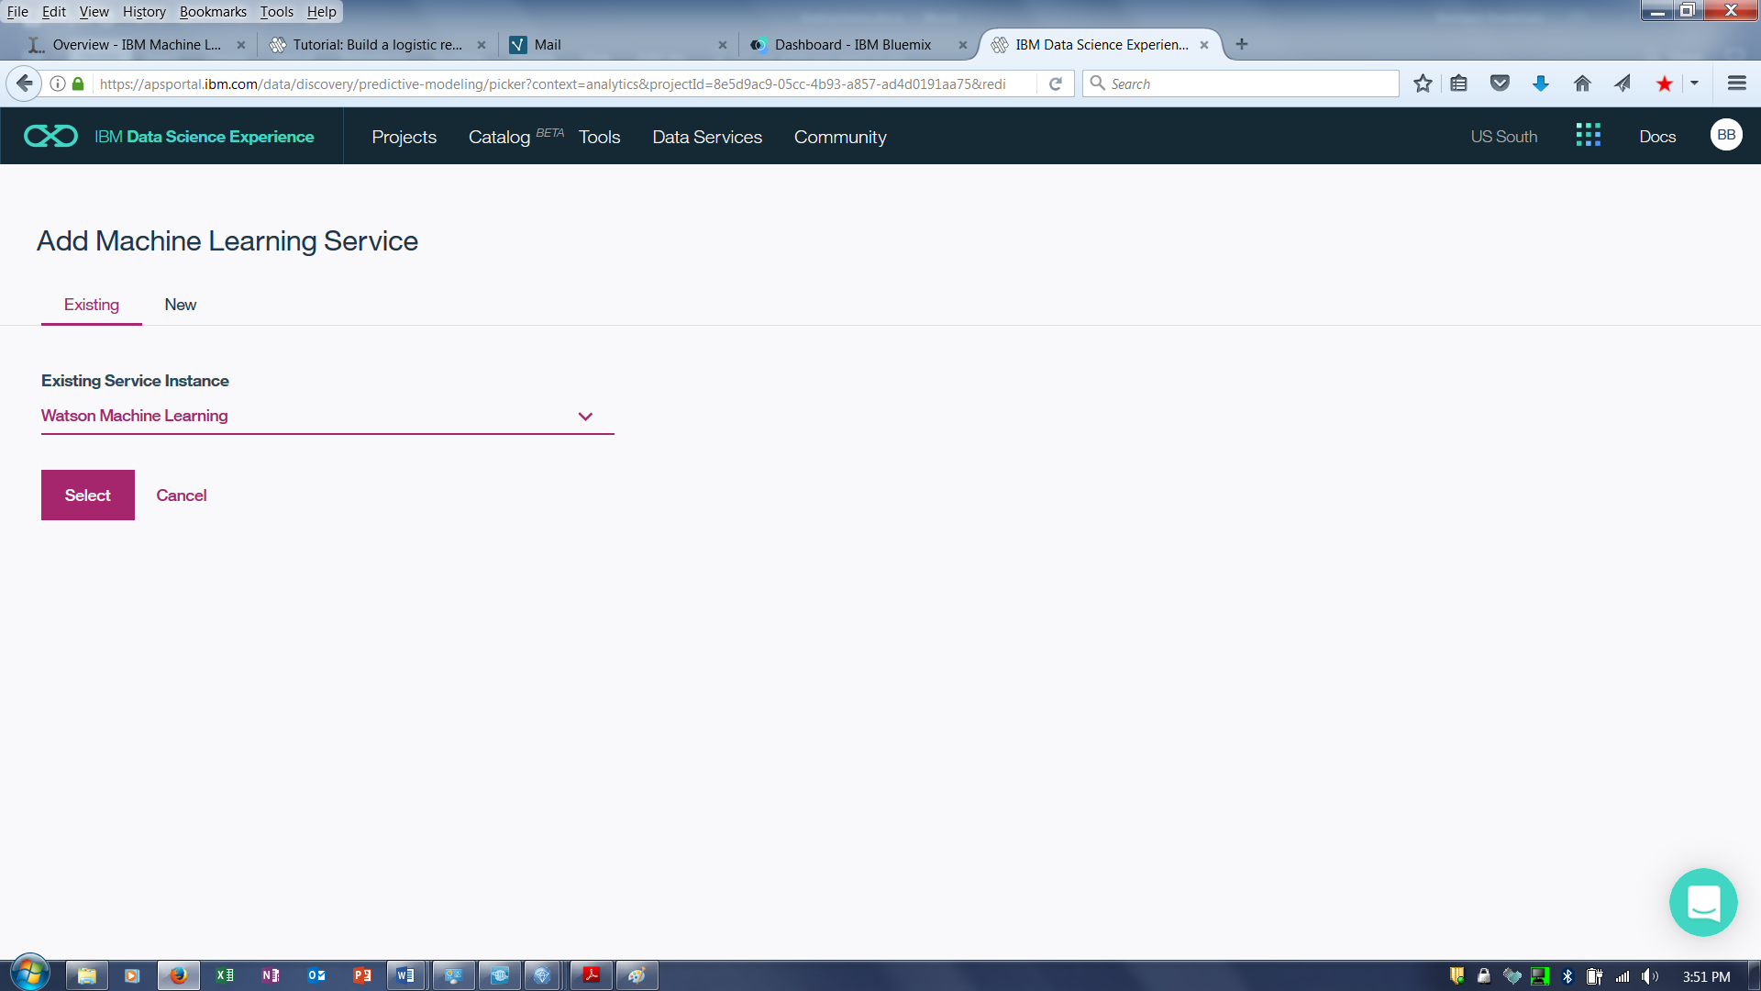

1. Click on the Project **Overview** tab.

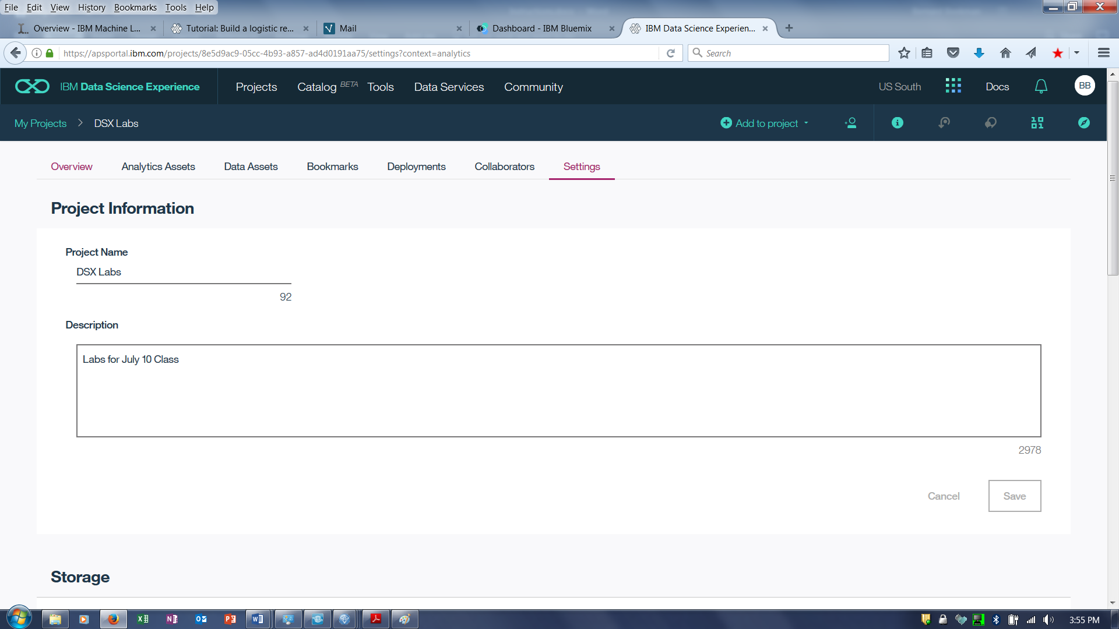

# Step 2: Adding a Data Asset to the DSX Labs project

1. Download the Titanic data file from

<https://github.com/jpatter/ML-POT/blob/master/Lab-2/data/titanic_cleansed.csv>

The data in this file has already been prepared and it ready to be input into the Modeling step.

1. Right click on Raw, and click on Save link as ….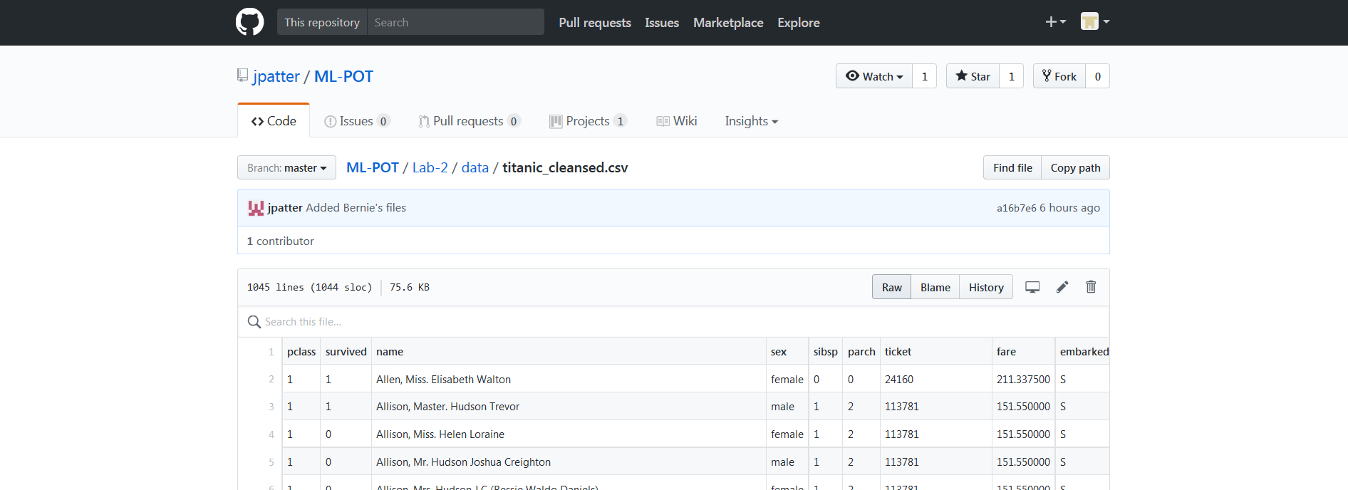
2. Go back to the DSX-Labs project. Click on **add data assets** or the  icon.

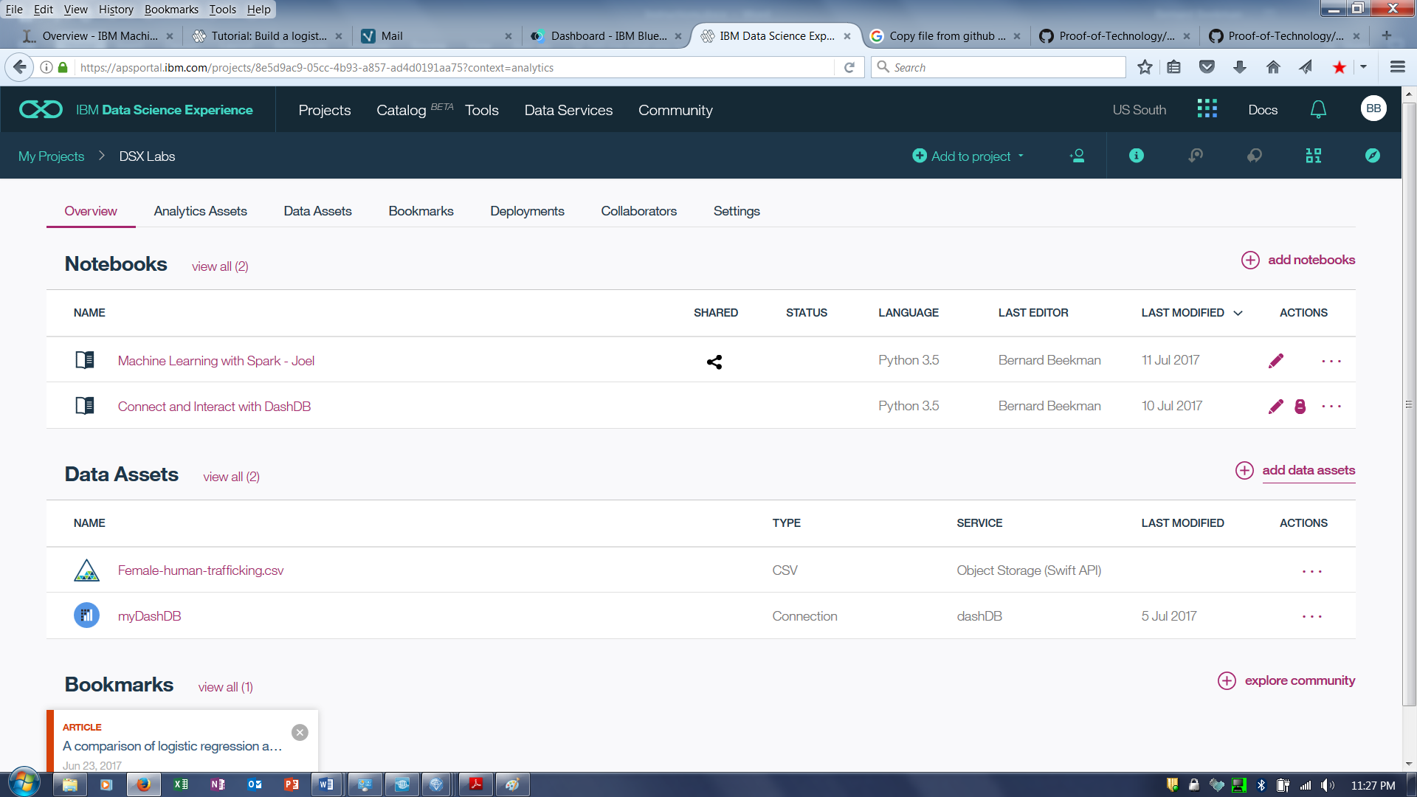

1. Click on browse and then go to the folder where the titanic_cleansed.csv is stored. Select titanic_cleansed.csv and then click Open.

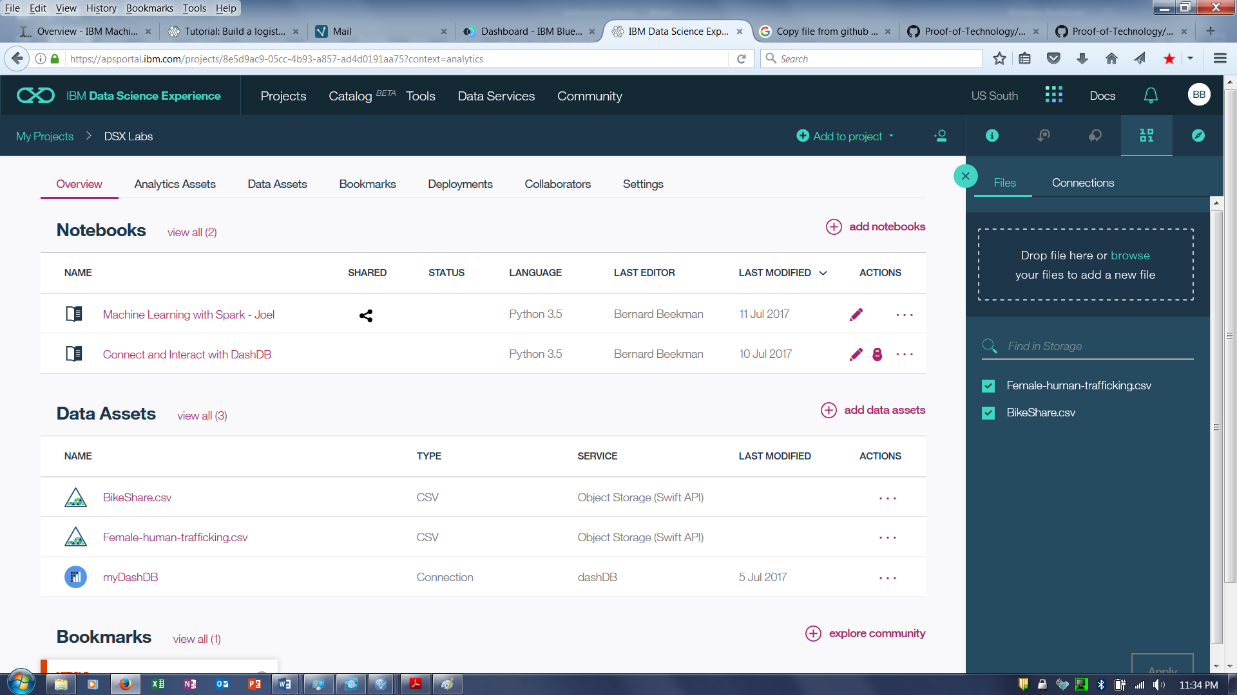

.

# Step 3: Create a Model to predict survival

1. Click on the Analytic Assets Tab



1. Click on the **add models**.

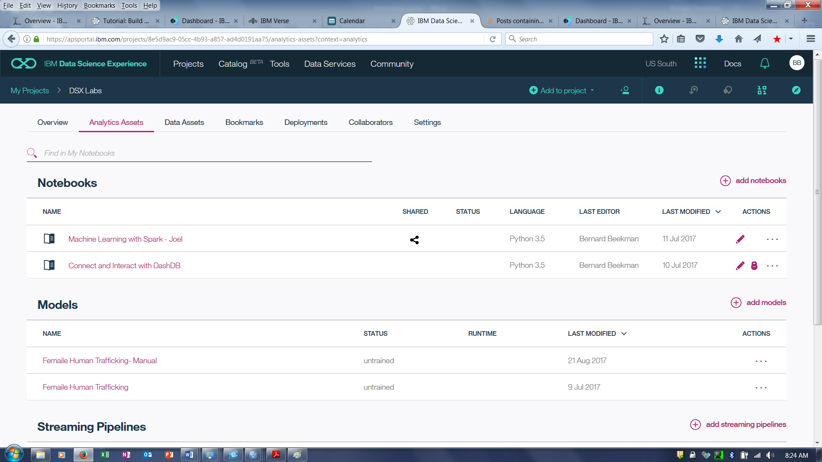

1. Enter the Model **Name**, **Description**, Select **Manual**, and click on **Create**.

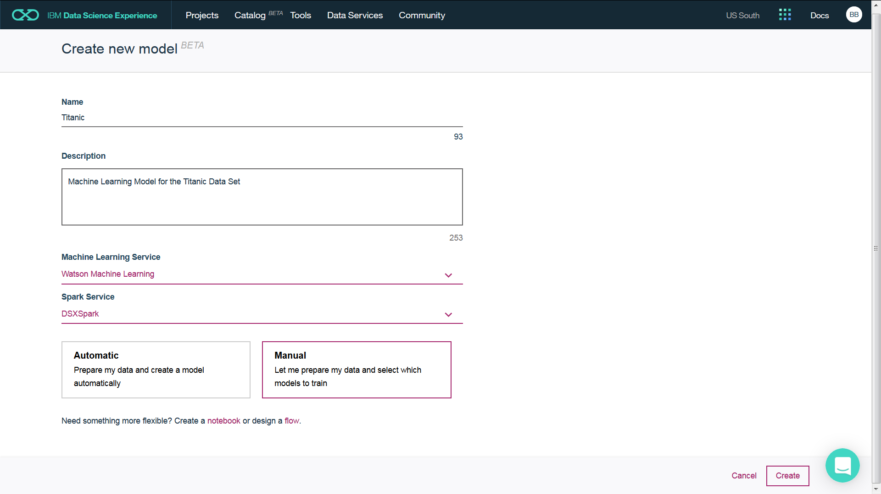

1. Click on the titanic_cleansed**.csv** and click on **Next**

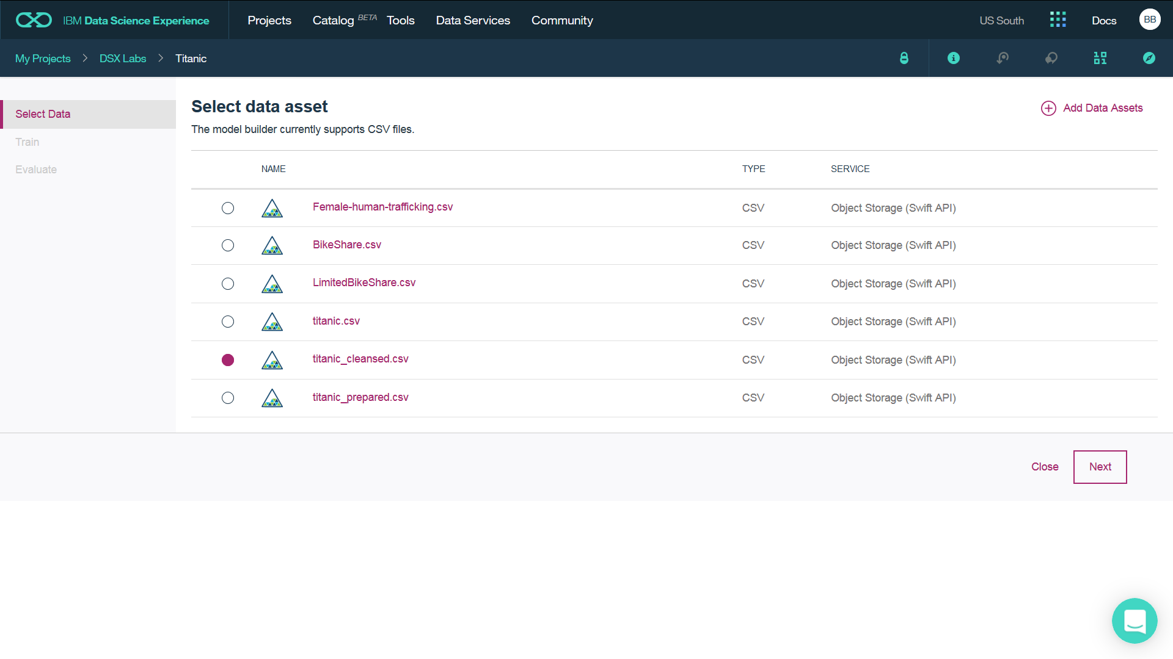

1. For **Column value to predict (Label Col)** select **survivor**. For **Feature columns** select the following features (**pclass,sex,sibsp,parch,fare,embarked,Age_Bucket**) . Click on the **Binary Classification** Box (which is suggested by the service). Adjust the **Validation Split** as desired. Click on **Add Estimators** to add the specific models to use.

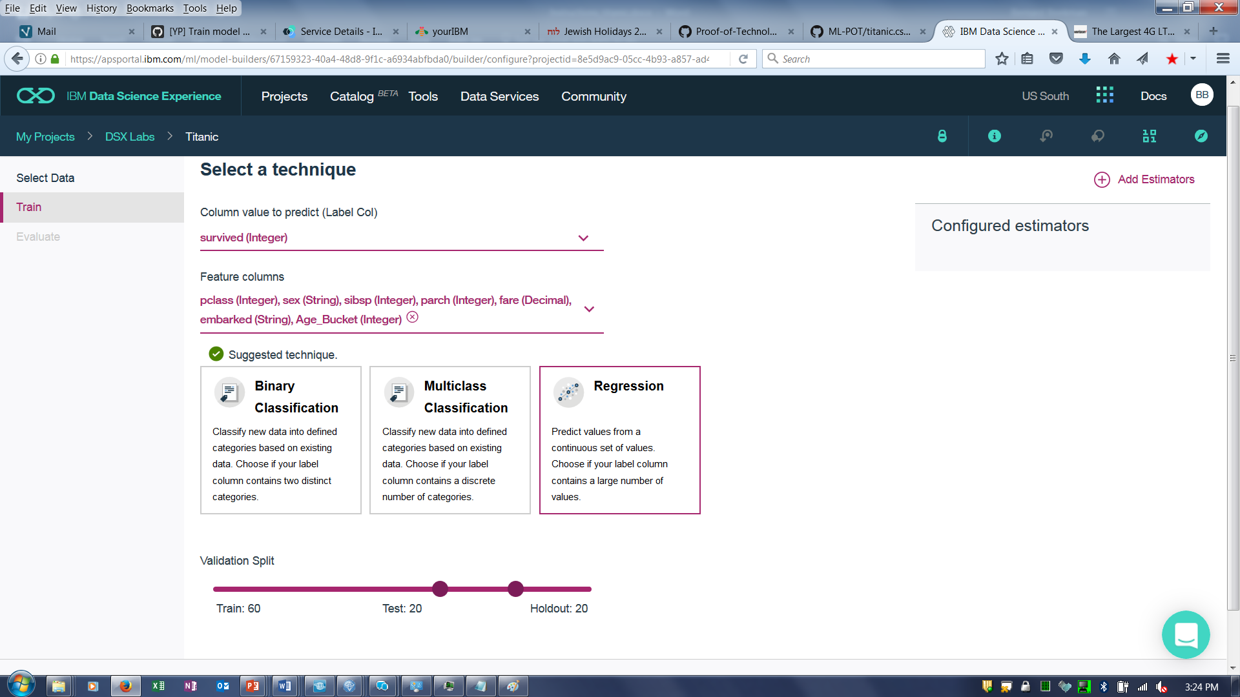

1. Select the **Logistic Regression**. Select **Add**.

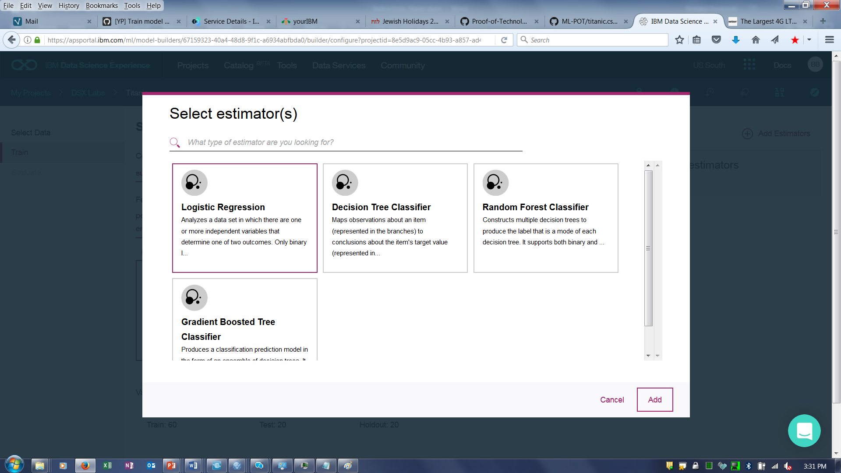

1. Select the **Next** button.

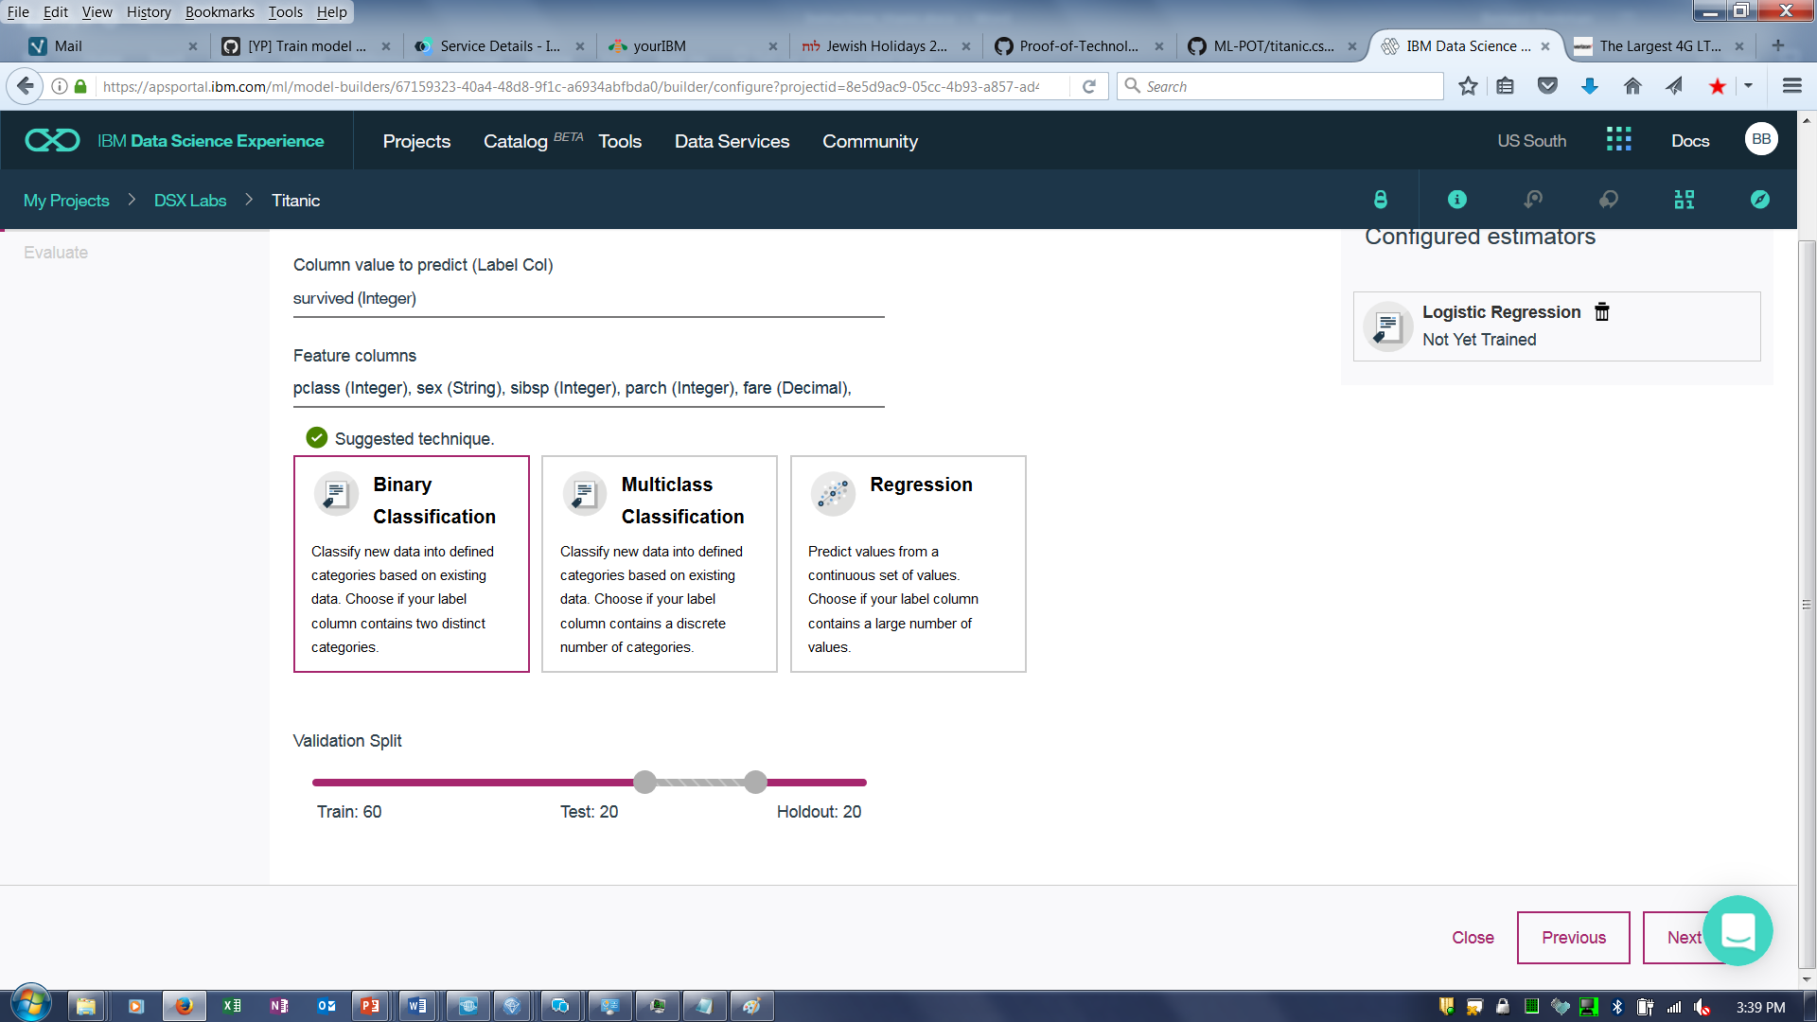

1. The system trains and evaluates each model If more than one model was selected, the models would be listed in descending order of quality with the best result at the top. Click on the **Logistic Regression** and then click **Save**.

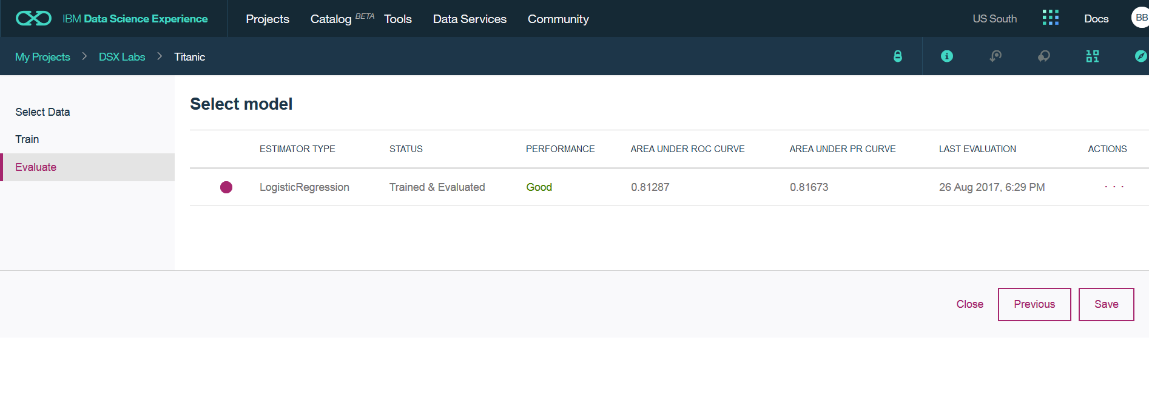

1. The system displays the model training summary. To run a sample prediction, select the **Predictions** tab

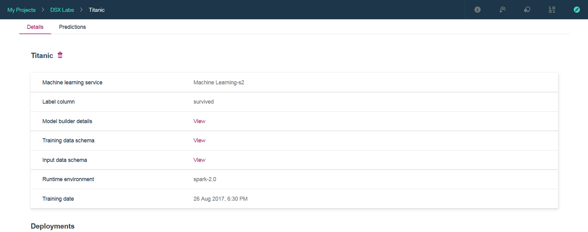

1. Enter values for the input features and then click on **Predict**.

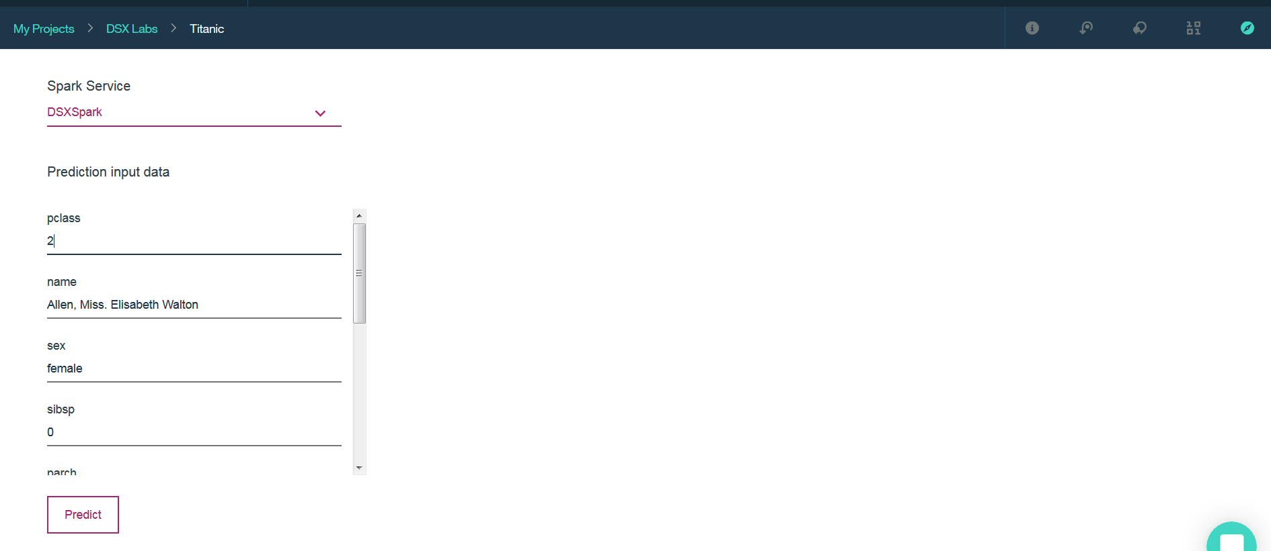

1. The prediction for survivor is displayed along with the confidence in the prediction.

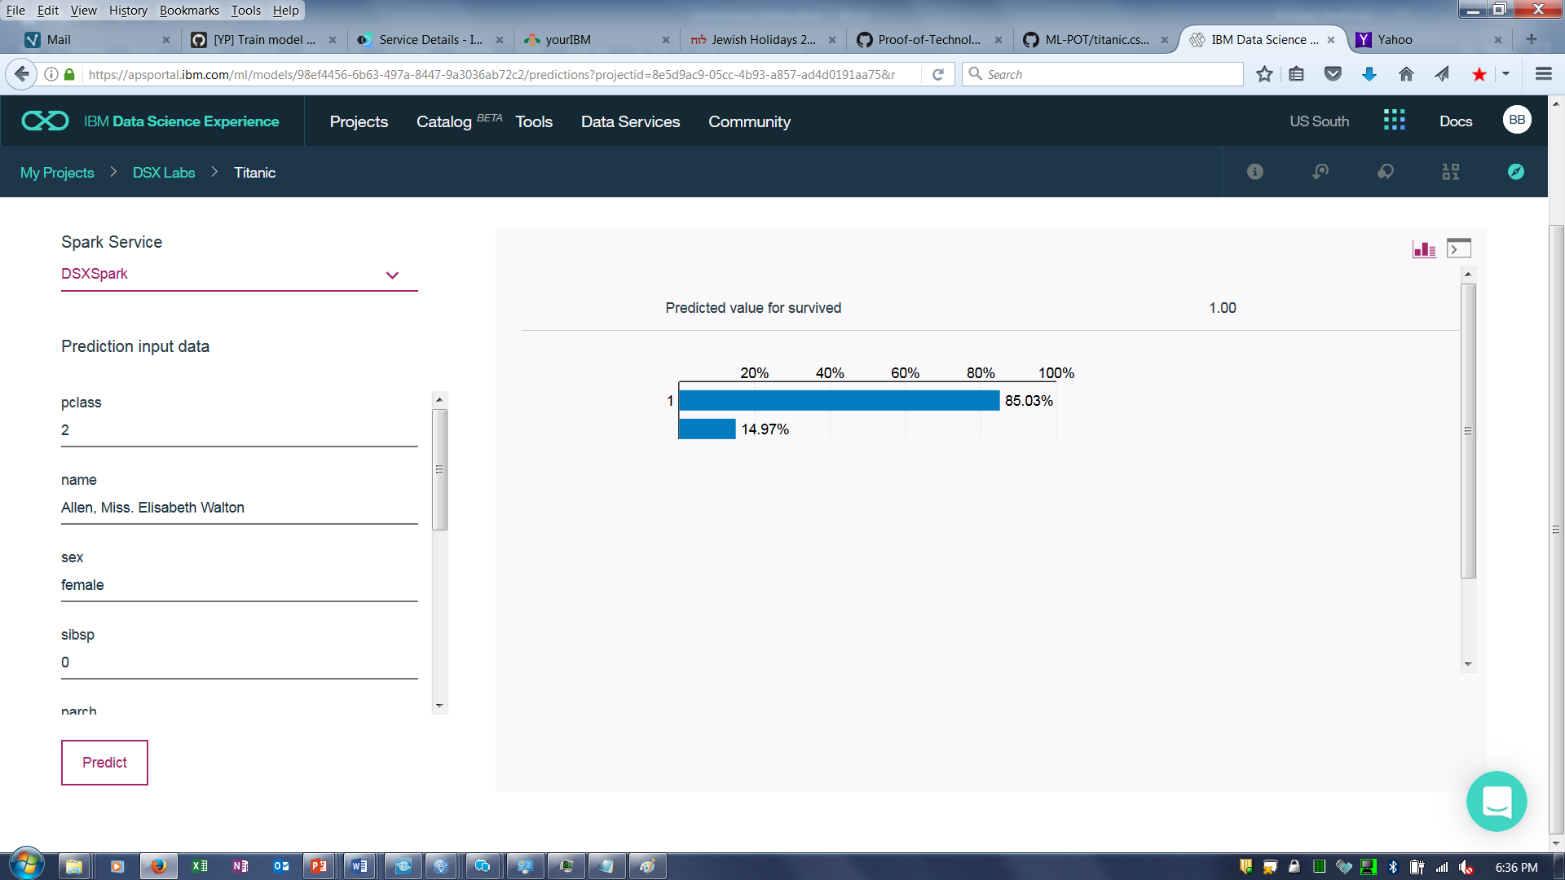

# Step 4: Deploying a Model

We can deploy the model to enable applications to invoke it via an API call.

1. Select the **Details** Tab
2. Scroll down to the **Add Deployments** option. Click on **Add Deployments**

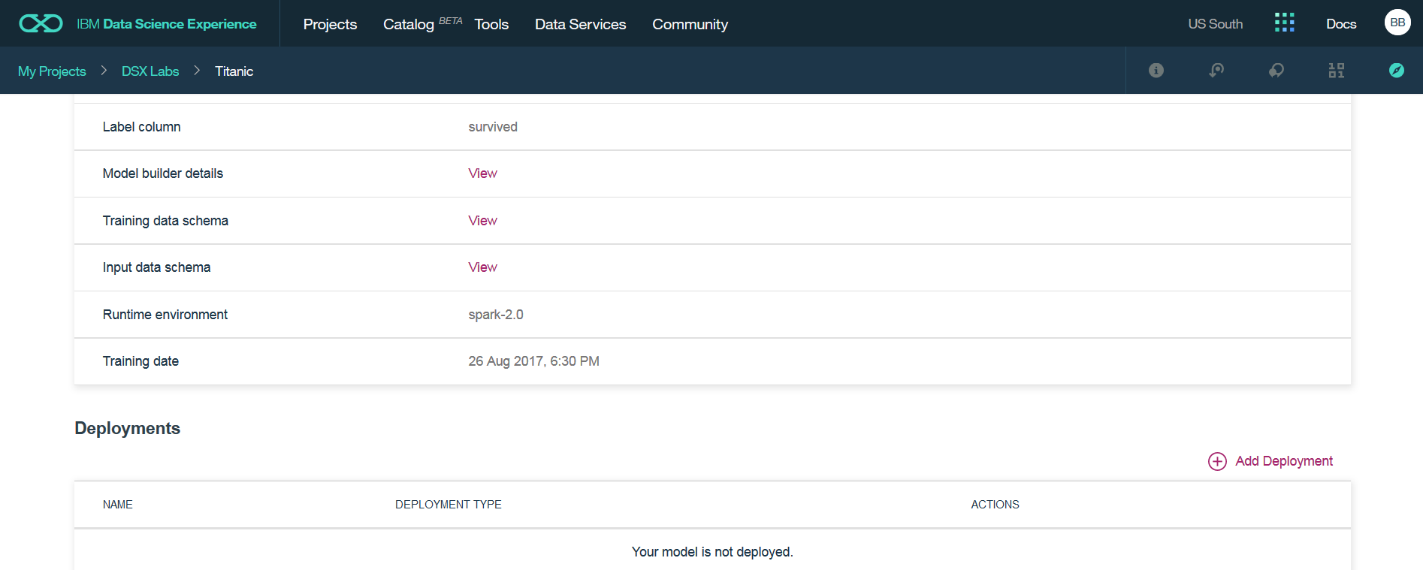

1. Select Online for **Deployment Type**, enter Titanic_Deployment for **Name**, and click on **Deploy**.

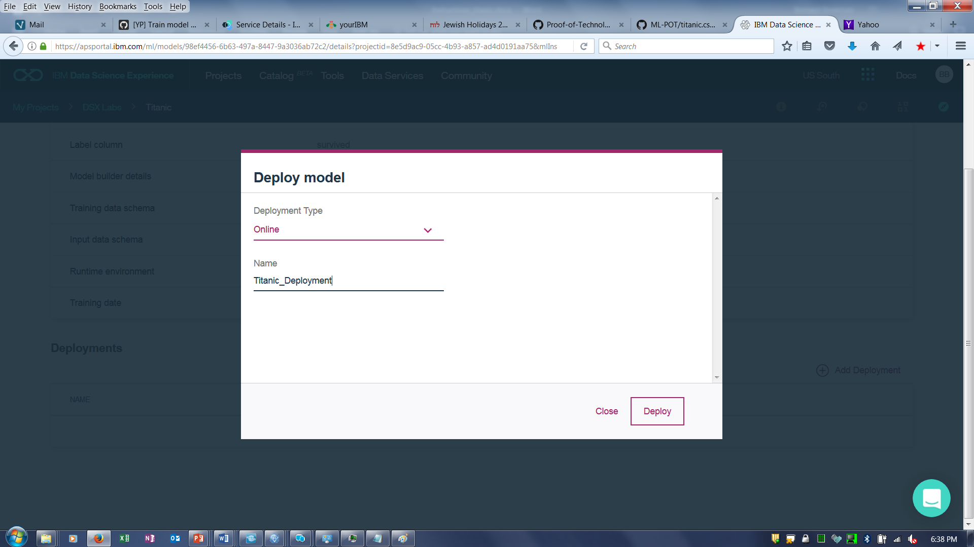

1. The system responds with an acknowledgement that the model was successfully deployed. Click on **Titanic_Deployment** to test the deployed API.

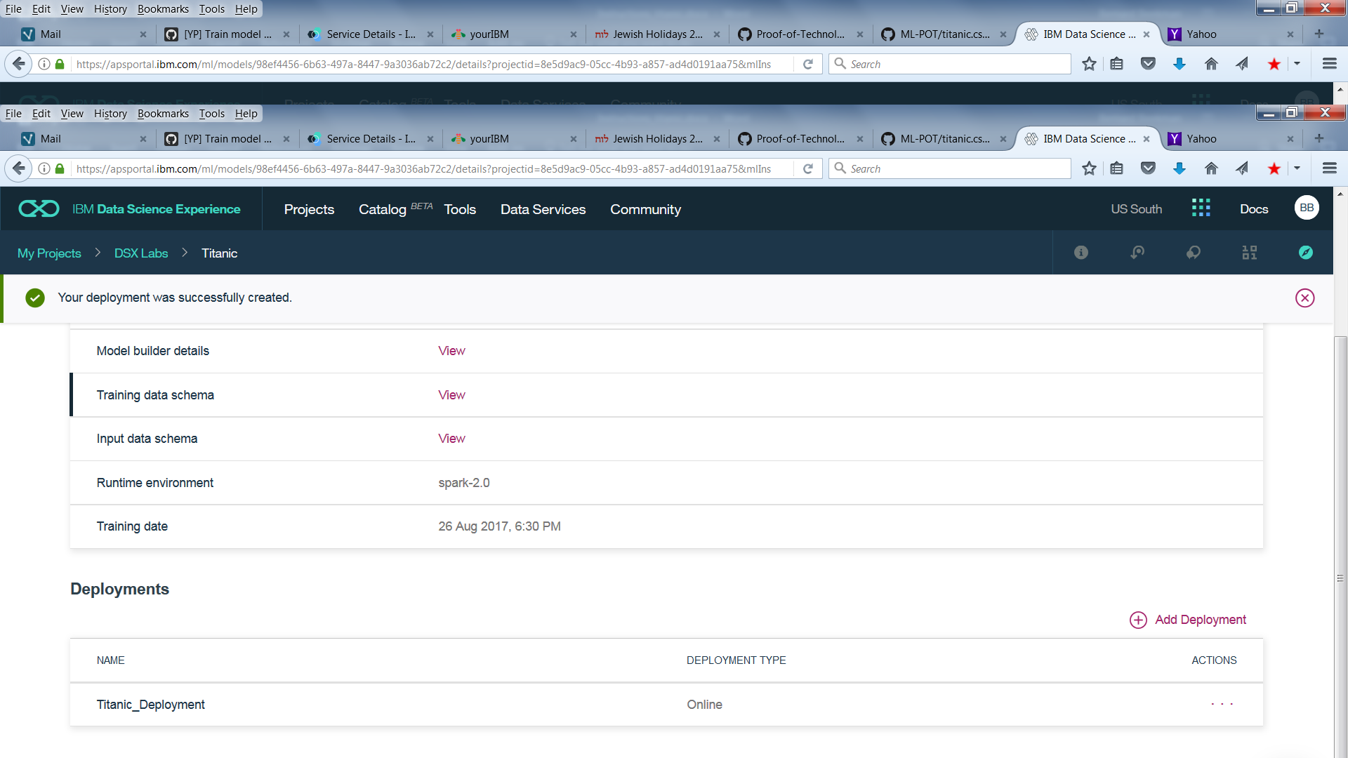

1. The system displays information about the deployed service including the endpoint to invoke by an application (e.g web application predicting survival). Click on **Test API** to test out the API.

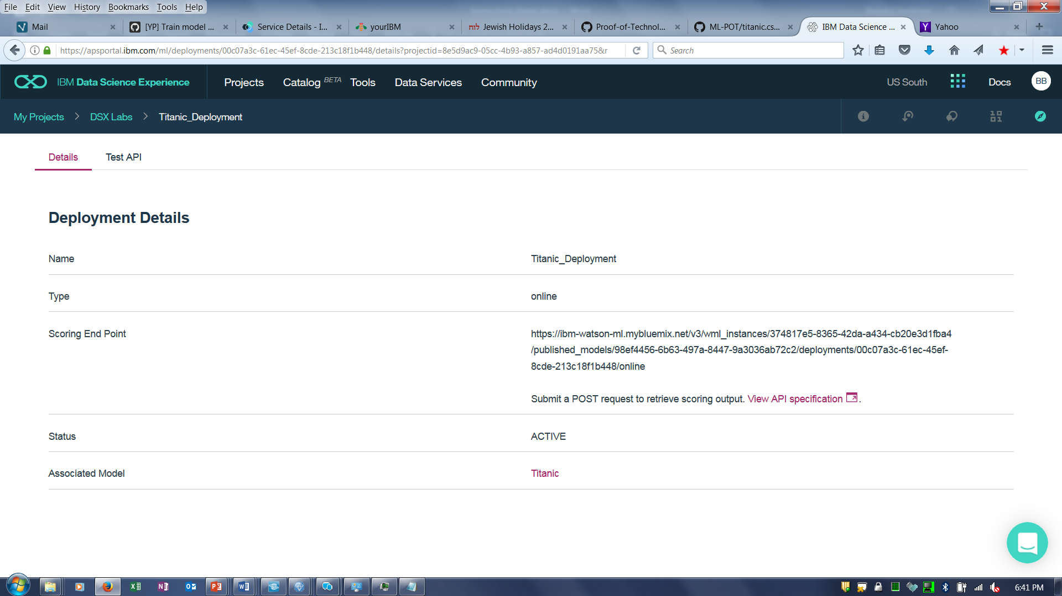

1. Enter values for the input fields and then click on **Predict.** Note that the values inputted for any of the fields not included in the model parameters (e.g. name) will not affect the prediction.

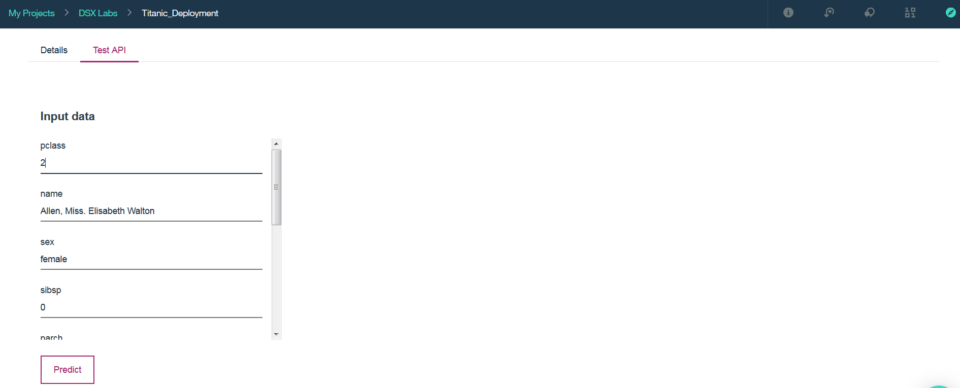

1. The predicted result is returned.

